United Nations Security Council (UNSC)  The Issue of the Strait of Hormuz  DELEGATION OF JAPAN | 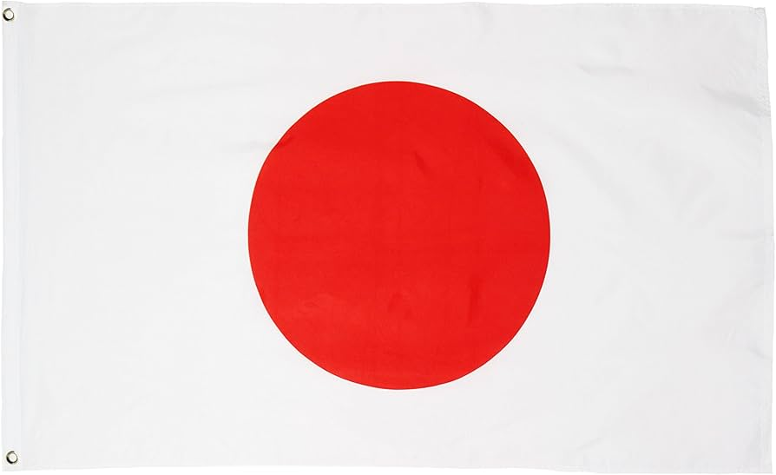

The Delegation of Japan views the Strait of Hormuz not merely as a regional waterway, but as the primary "jugular vein" of the global energy economy. As an island nation whose industrial civilization is sustained almost entirely by seaborne energy trade, Japan possesses a unique, unparalleled understanding of the legal and strategic responsibilities inherent in managing international maritime chokepoints.
The current situation in the Strait—characterized by naval provocations, the seizure of commercial vessels, and escalatory rhetoric—threatens the energy security of the entire international community. Japan imports ninety percent of its crude oil and the overwhelming majority of its liquefied natural gas through the Strait. Therefore, any disruption to transit passage is not just a regional concern, but a direct threat to Japan’s national economic stability and the development goals of the Global South.
Japan remains a steadfast, unambiguous advocate for the United Nations Convention on the Law of the Sea (UNCLOS). Specifically, Japan emphasizes that Article 38 (Right of Transit Passage) constitutes customary international law. This right is non-suspendable. While Japan acknowledges the legitimate security concerns of littoral states, we maintain that "security" cannot be used as a pretext for the unilateral obstruction of international commerce.
Furthermore, Japan expresses concern regarding the "hyper-militarization" of the Strait. The deployment of vast naval armadas by non-regional powers, while framed as "defensive," has historically led to tactical miscalculations and strategic catastrophes. Japan believes that a sustainable solution must be rooted in multilateralism, not unilateral naval dominance.
Japan occupies a unique diplomatic position in this Council. As a treaty ally of the United States, we are committed to the rules-based international order; however, we maintain a historically unique, pragmatic, and constructive relationship with the Islamic Republic of Iran. Japan has historically rejected unilateral sanctions that bypass the UN framework, believing that economic strangulation often leads to maritime escalation.
Drawing from our successful, independent diplomatic engagement and dialogue with regional actors, Japan is prepared to serve as a neutral bridge between the P5 and regional states. We believe the path forward requires a transition from a "Security through Deterrence" model to a "Security through Cooperation" model.

The Delegation of Japan proposes the following three-pillar framework for the Security Council’s consideration:
- Establishment of a UN Maritime Monitoring Mission (UNMMM): A neutral, UN-mandated maritime observation forum operating independently of any single nation's command structure to monitor compliance and coordinate technical maritime safety.
- Revival of Multilateral Diplomatic Frameworks: A Council-endorsed resumption of regional security dialogue paired with a freeze on unilateral economic and naval escalations by non-littoral states, conditioned upon the cessation of vessel seizures.
- International Energy Stabilization and Infrastructure Protection: The legal designation of oil and gas tankers as "neutral civilian infrastructure" during periods of heightened tension, ensuring they remain exempt from political or military targeting, backed by strategic reserve coordination mechanisms to protect vulnerable economies.
Japan urges this Council to move beyond the binary of confrontation. The Strait of Hormuz must remain a corridor of commerce, not a theater of war. Japan stands ready to facilitate the dialogue necessary to ensure that international law prevails over geopolitical rivalry.

